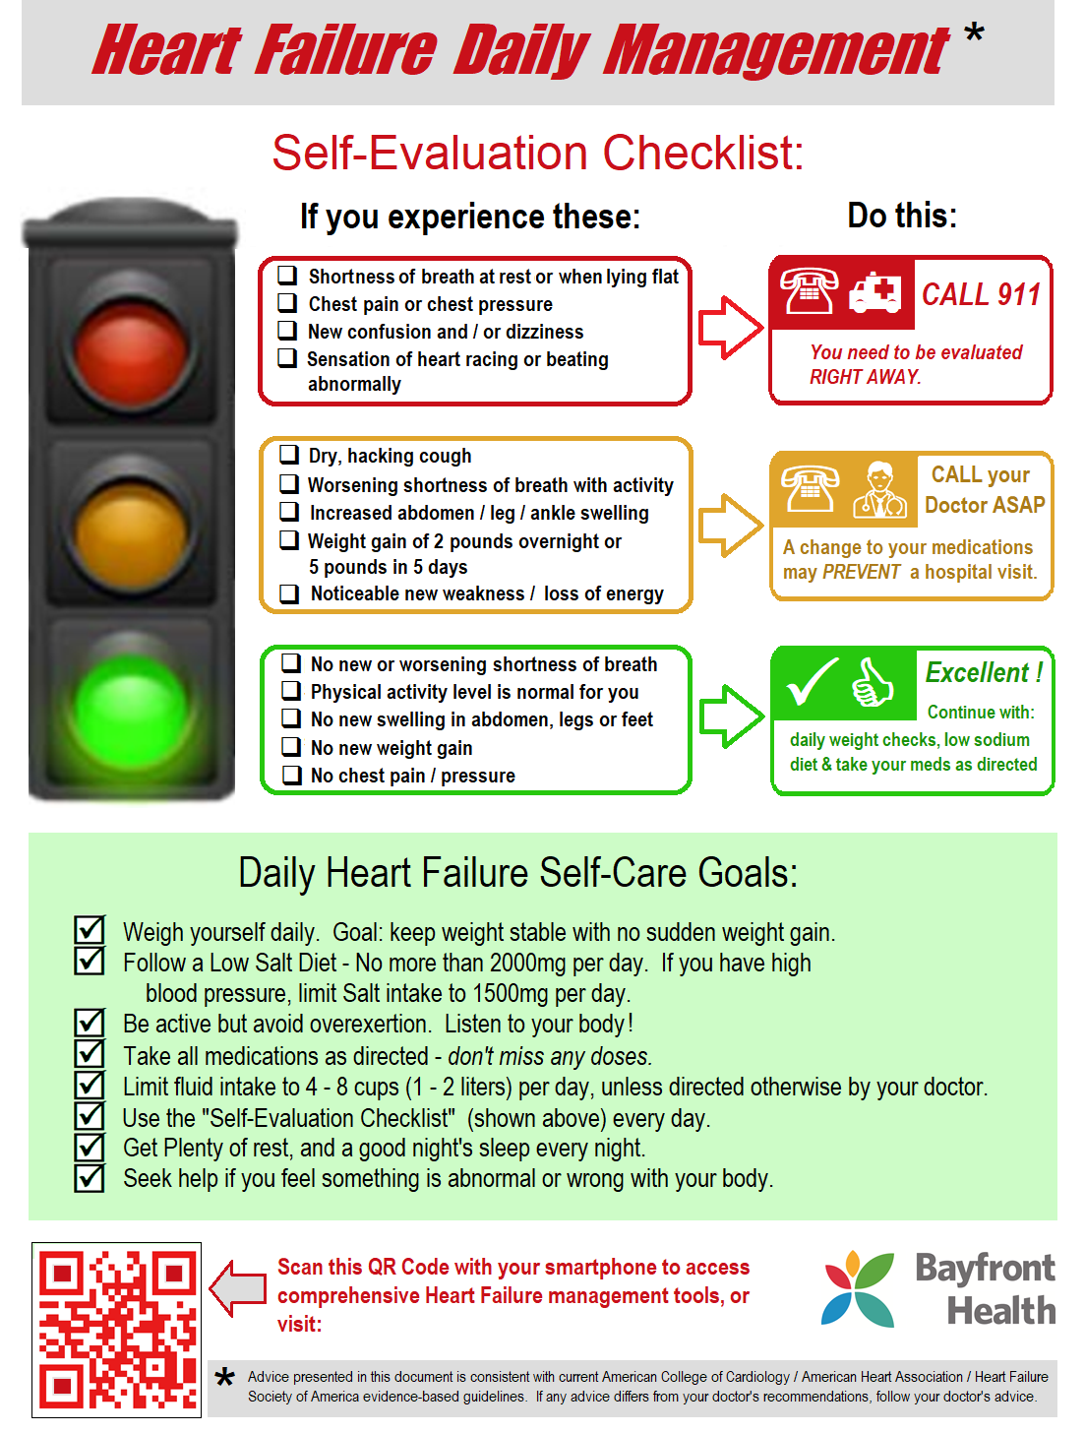

[**HeartFailureResources.com**](http://www.ecgtraining.org/id35.html)